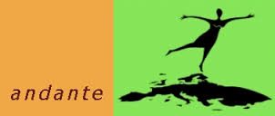

**Review of the sessions**

**April –October 2020**

__________________________________________________________

Dear CoCoa

I try to give you a small insight into the work of the Conference of NGOs since April 2020. Covid-19 has met us in a way we all could not have imagined in January 2020. So the April session was cancelled completely. In May we were then contacted and asked to choose from a selection of topics, all about Covid-19 and how it affects the work of the NGOs. This was in preparation for the conference in June. I have also listed the relevant topics under the June session. They can all be viewed under the corresponding link.

**2020 Spring session (20-24 April 2020) CANCELLED**

**2020 Summer session (22-23 June 2020)**

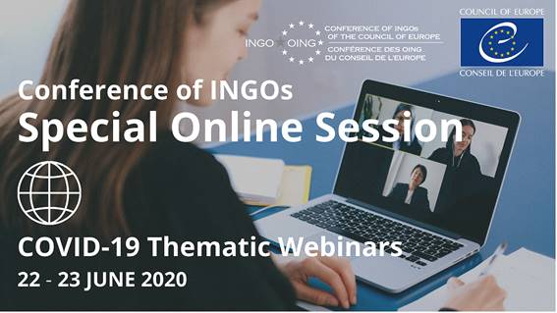

**Thematic webinars (You can watch all of them on the website,**

**coe.int→Conference of INGOs → Sessions → summer session)**

* Let's build a better future together! Strengthening Participative Democracy and Civil Society when building the Post-Corona World.

- What lessons from Covid-19 should be taken for education and the digital era

- How to reduce inequalities and poverty throughout the upcoming economical and ecological transitions?

* Migrants and refugees facing the Covid-19 crisis, what lessons for the post-

pandemic time?

____________________________________________________________________

**COVID-19: Videos - INGOs under lockdown get involved and prepare for the future**

A video, that shows, how the pandemic affected the work of NGOs, interesting statements (coe.int/en/web/ingo, Covid-19 response)

________________________________________________________

**2020 Autumn session - ONLINE (12-16 October 2020)**

The Autumn session of the Conference of INGOs of the Council of Europe was held in its entirety via video conferences from 12 to 16 October. You will find the agenda for the week  under **www.coe.int/en/web/ingo/october-2020**

A second part of the plenary session will take place on 15 and 16 December 2020

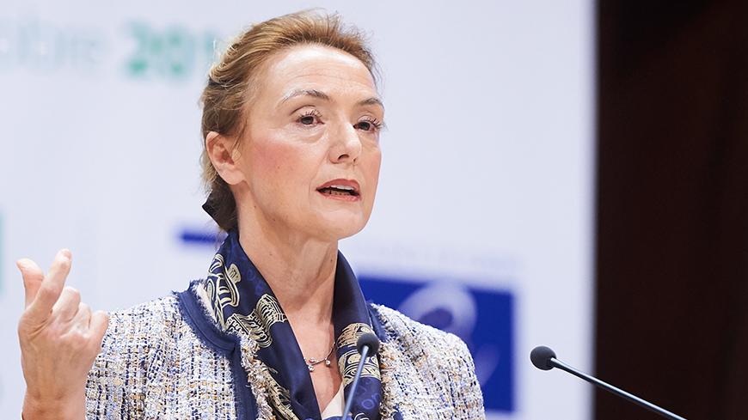

Marija Pejcinović Burić, Secretary General of the Council of Europe

**“The virus is destroying many lives and much else of what is very dear to us. We should not let it destroy our core values and free societies,”**

**__________________________________________________**

The Secretary General pointed out that the NGOs have a role to play, it is also about sticking together in Europe.

It was discussed that there are particularly vulnerable persons and groups who should be protected.

Some of them are mentioned here.

***Women***

*Thousands of women are in lock-down with violent partners made more violent through stress. They can’t get away, they can’t ring for help, their children are at home, in harm’s way. Women are dying, unable to call the police or find an escape route.*

*This crisis is exposing the true extent of domestic violence. It's a wake-up call to action: now and in the future.*

*Our*[*Istanbul Convention*](https://www.coe.int/en/web/human-rights-channel/istanbul-convention)*equips countries to prevent domestic violence and now it’s needed more than ever.  
Marceline Naudi, President of the Group of Experts against violence against women and domestic violence explains how it is now more important than ever.*

***Children***

*Imagine being trapped with your abuser and there's no way out. For vulnerable children in families, children’s homes and other institutions that is now the harsh reality.*

*Or imagine you’re online, trying to while away the time in lock down, potential prey for sex offenders looking to groom children via the Internet.*

*Whilst parents, guardians and governments are busy coping with COVID-19, children are being put at risk. We’re calling for governments*[*to step up protection.*](https://www.coe.int/en/web/portal/-/covid-19-confinement-states-must-step-up-protection-of-children-against-sexual-exploitation-and-abuse-says-lanzarote-committee)

***Refugees and asylum seekers***

*Thousands of people seeking a life away from conflict are waiting at Europe’s borders and at special camps inside Europe to discover their fate. Already difficult situations are being made more difficult by the pandemic.*

*We’re helping governments with*[*guidance*](https://www.coe.int/en/web/portal/-/fundamental-rights-of-refugees-and-migrants-at-european-borders)*and calling for special*[*protective measures*](https://www.coe.int/en/web/portal/-/commissioner-calls-for-release-of-immigration-detainees-during-covid-19-crisis)*, making sure we don;t forget the human rights of this special group. Thanks to our*[*European Refugee Passport*](https://www.coe.int/en/web/portal/-/council-of-europe-and-unhcr-support-member-states-in-bringing-refugee-health-workers-into-the-fight-against-covid-19)*doctors, nurses and other qualified medical staff can more easily join the health services in their new countries .*

***People with disabilities***

*When you need help to eat, drink or bathe, how can you self-isolate or keep social distance?*

*People with disabilities are already more under threat than others during the pandemic.*[*We’re joining calls for governments*](https://www.coe.int/en/web/portal/-/persons-with-disabilities-must-not-be-left-behind-in-the-response-to-the-covid-19-pandemic)*to bring in special measures to keep them safe.*

An important part of our conferences is also to make recommendations and resolutions to national governments.

In the autumn session we adopted a recommendation calling on member states to implement the Istanbul Convention. In some states such as Bulgaria, Poland, Slovakia, Hungary, we have seen regression in this respect, also with the participation of religious groups**.**

CONF/PLE(2020)REC2:

Recommendation in support of the Istanbul Convention

https://rm.coe.int/conf-ple-2020-rec2-en-istanbul-convention/16809fe020

CONF/PLE(2020)RES1:

Resolution on access to digital technology in Europe and the responsibility of member States

https://rm.coe.int/conf-ple-2020-res1-en-digital-technology/16809feab0

in all the conferences and discussions, it has again become clear again that it is more difficult for umbrella organizations, such as Andante, to specifically address certain issues.

It is clear, however, that civil society has an important role to play, especially now. The impressive example of Belarus has shown that international interference by NGOs can also carry weight. For days and weeks, protests have been going on there, mainly and only by NGOs and the civilian population, under difficult conditions with consequences such as imprisonment, etc. People are currently resisting the regime of Lukashenko

So if you have read all this, it’s time to learn more. Maybe you would like to start the test,

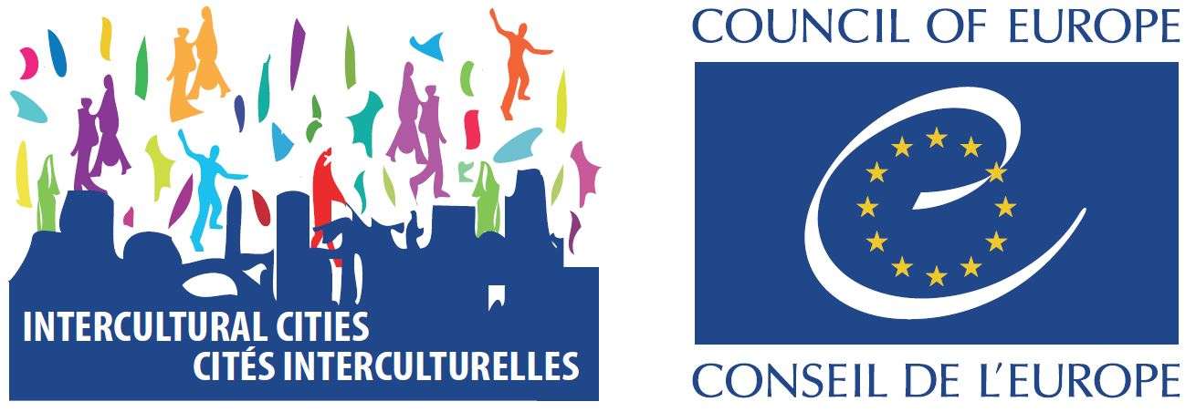

|  |
| --- |
| Intercultural Citizenship Test |

## Diversity – Knowledge